AWS QuickSight

1. Log into AWS and click on services.
2. Click on QuickSight and create a free standard account using your AWS account

Note: you will have to create an “organization” name

1. Click New Analysis on the QuickSight home screen

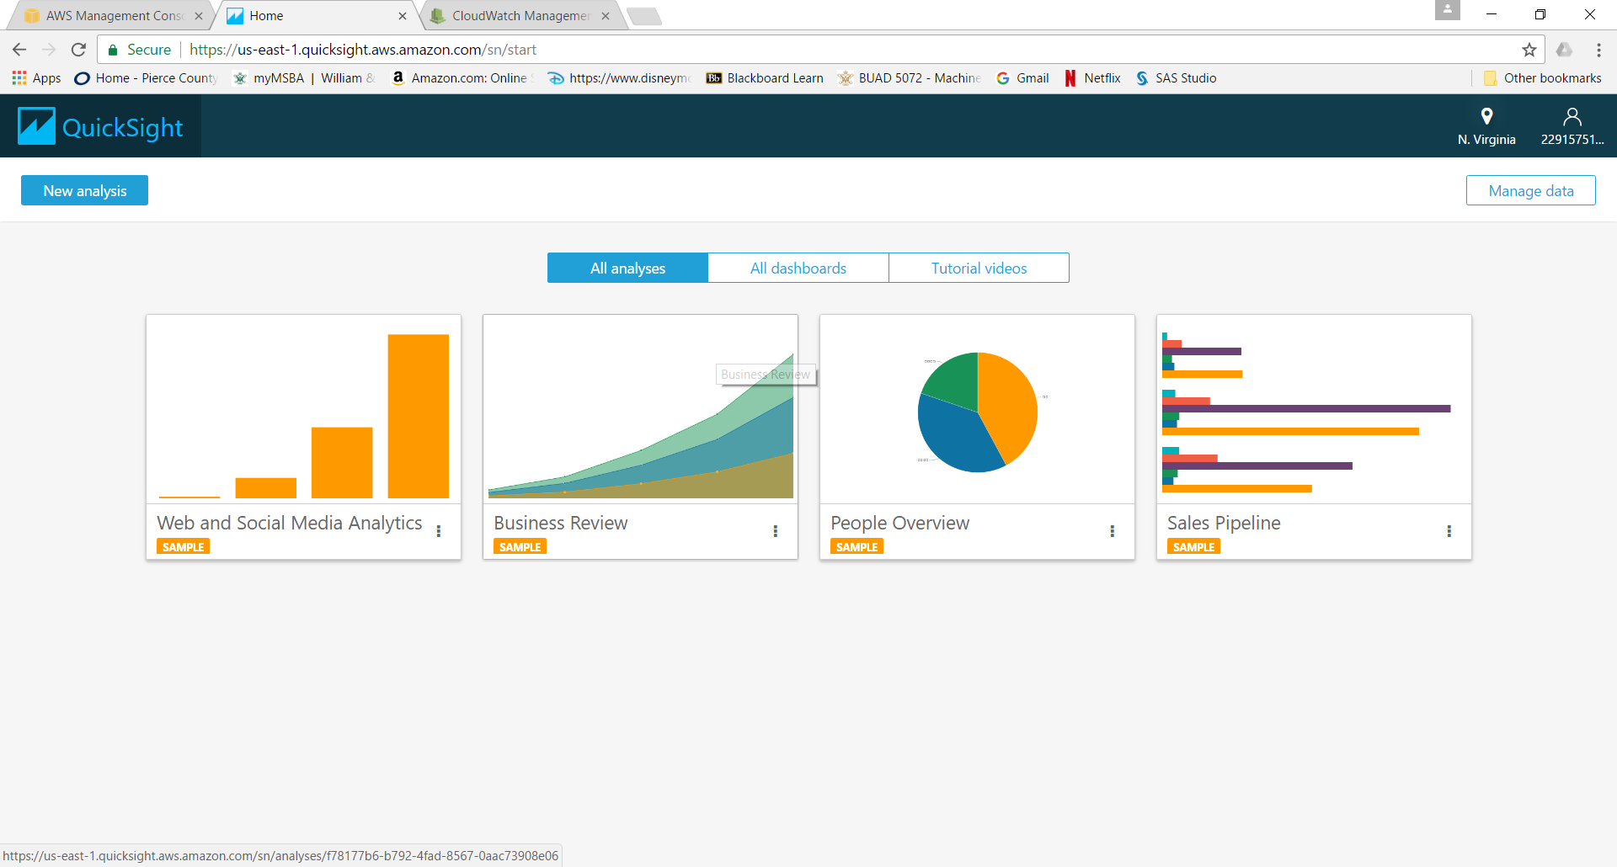

1. Click the Data labeled Web and Social Media Analytics

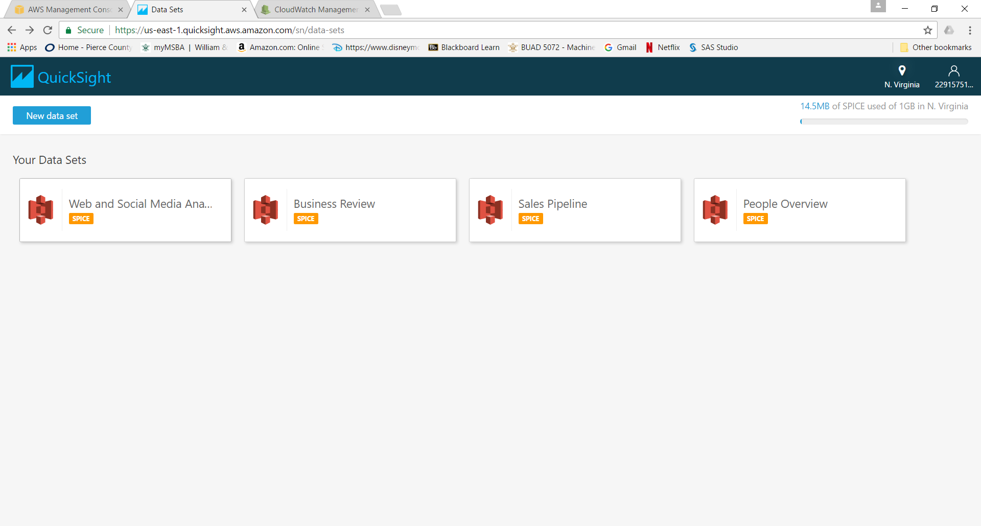

1. You can now create your first visual by choosing the Date field

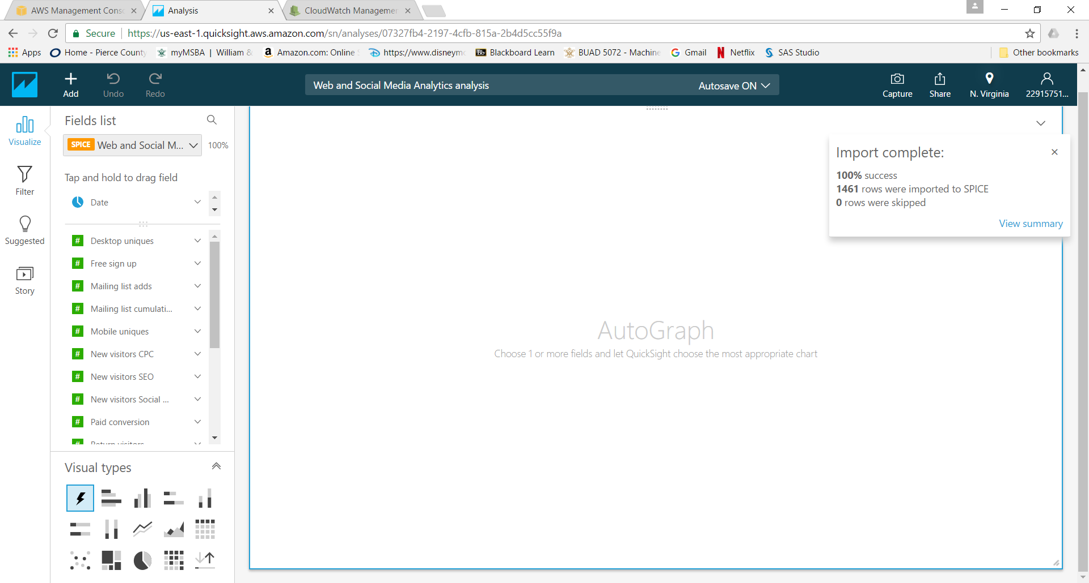

1. Next, click on Website Visits. Autograph should produce the following line chart:

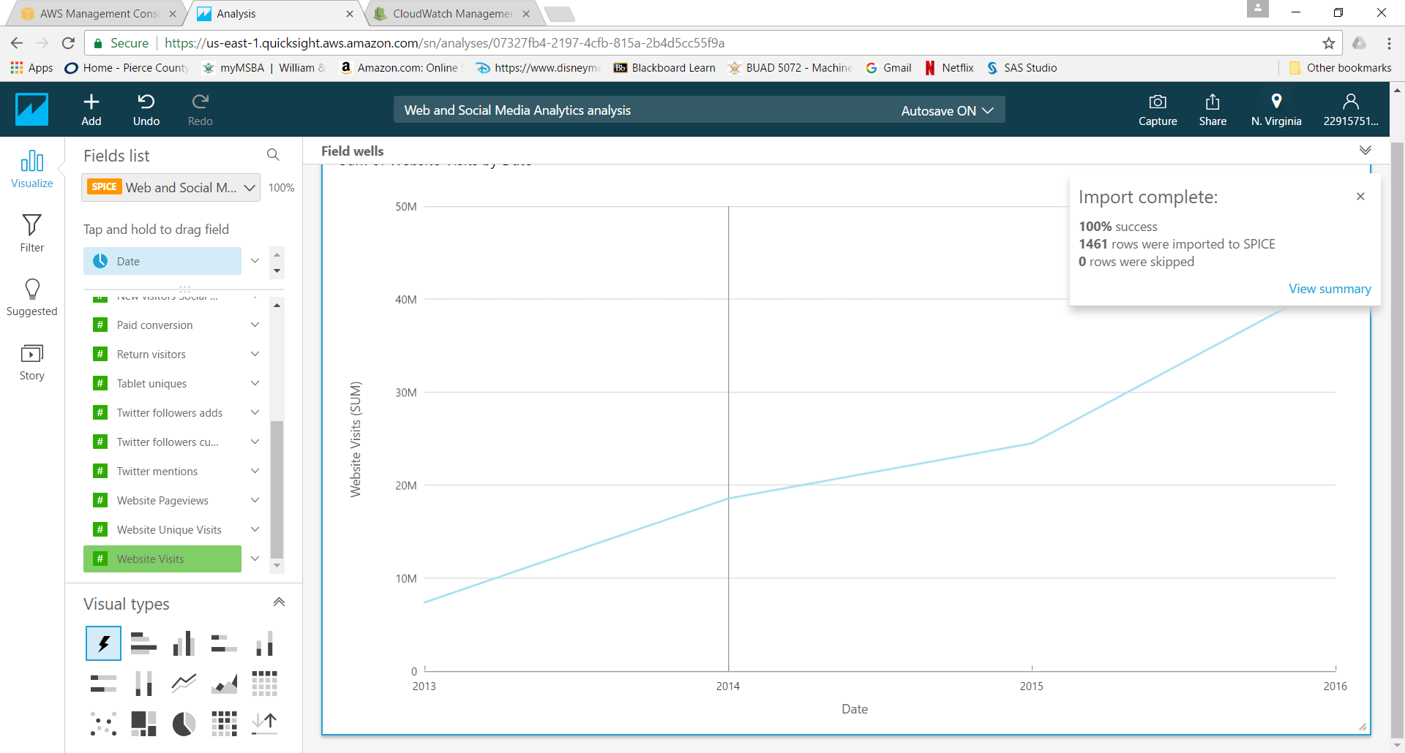

1. Click on Return visitors to add a second line to the chart:

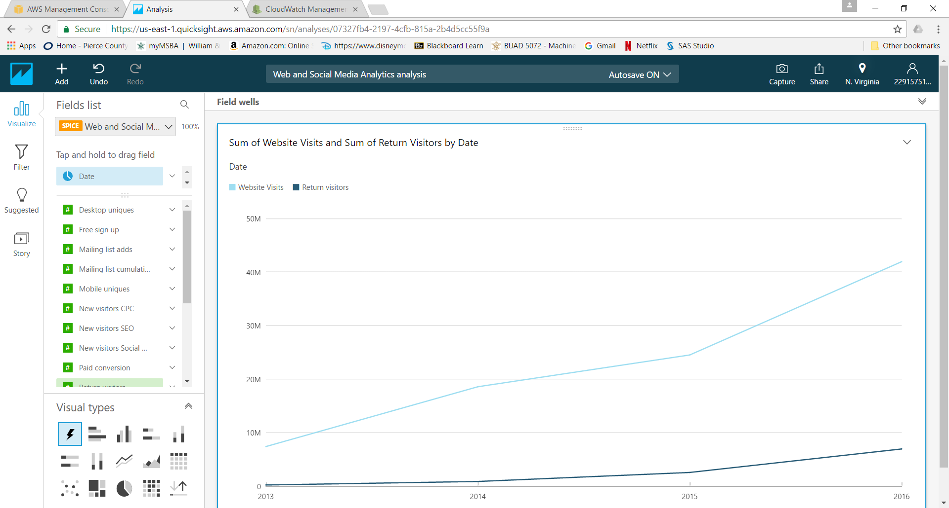

1. Add Website Pageviews and Website Unique Visits to the chart:

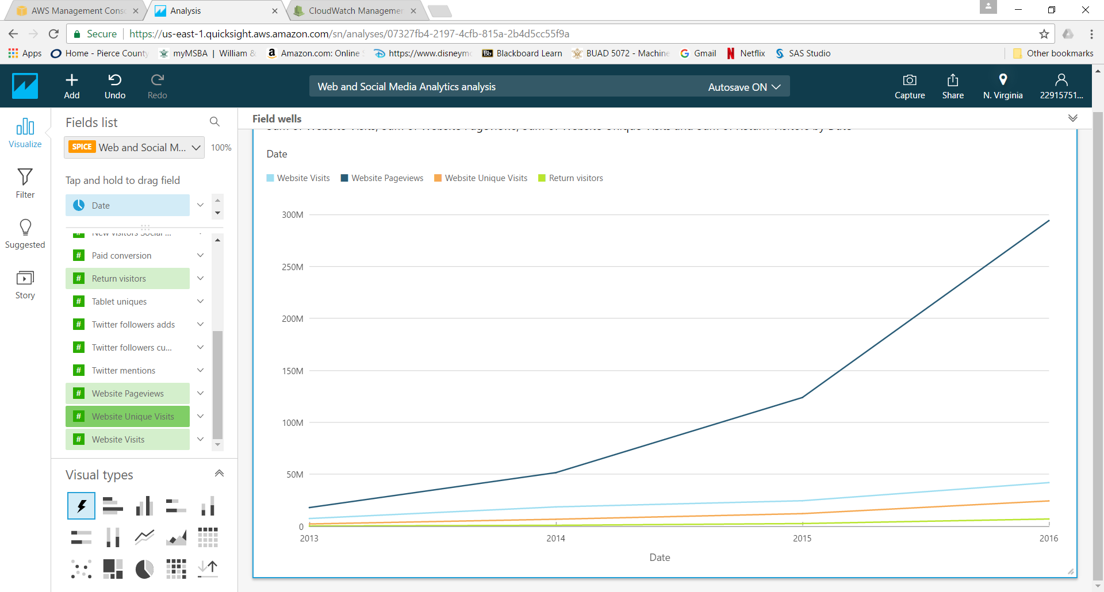

1. Click Field wells (just above the chart) and format Date as MONTH instead of YEAR

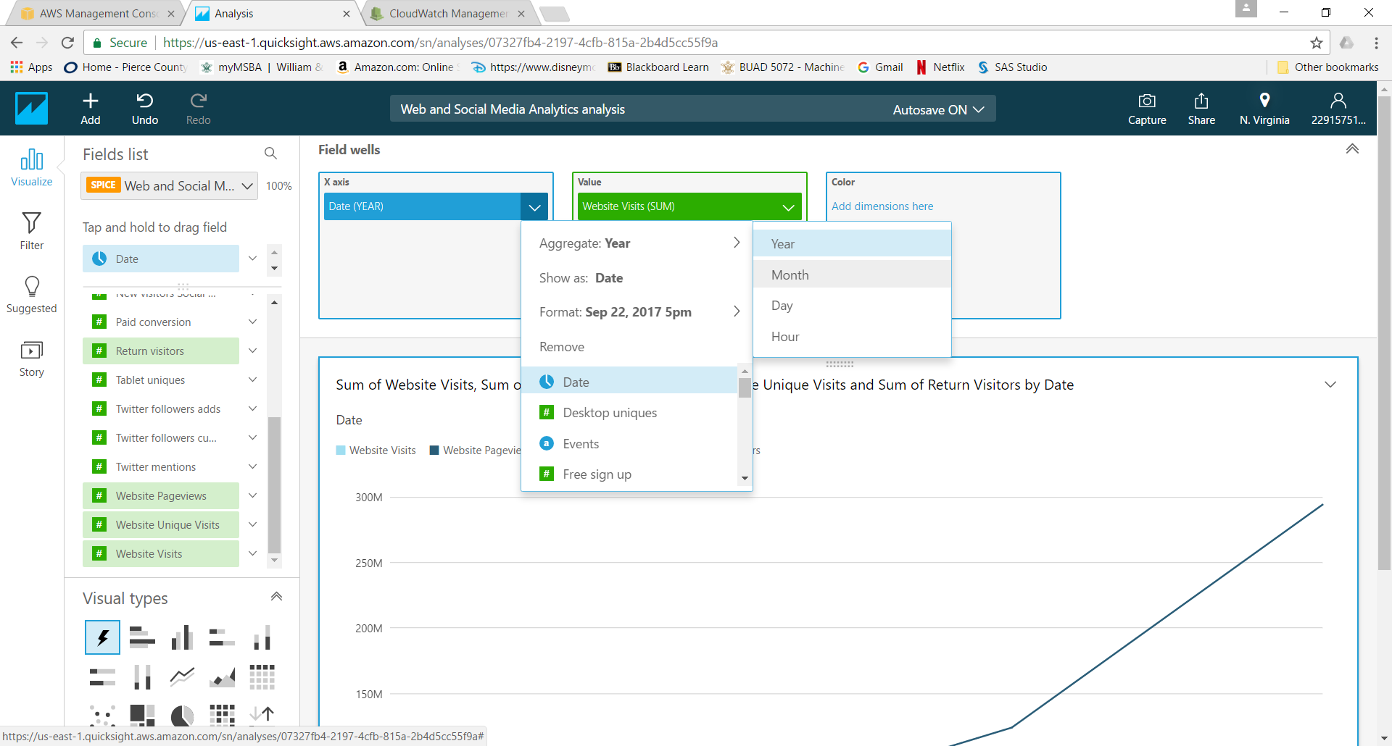

1. Adjust the blue slide bar at the bottom to focus on different time ranges in the data

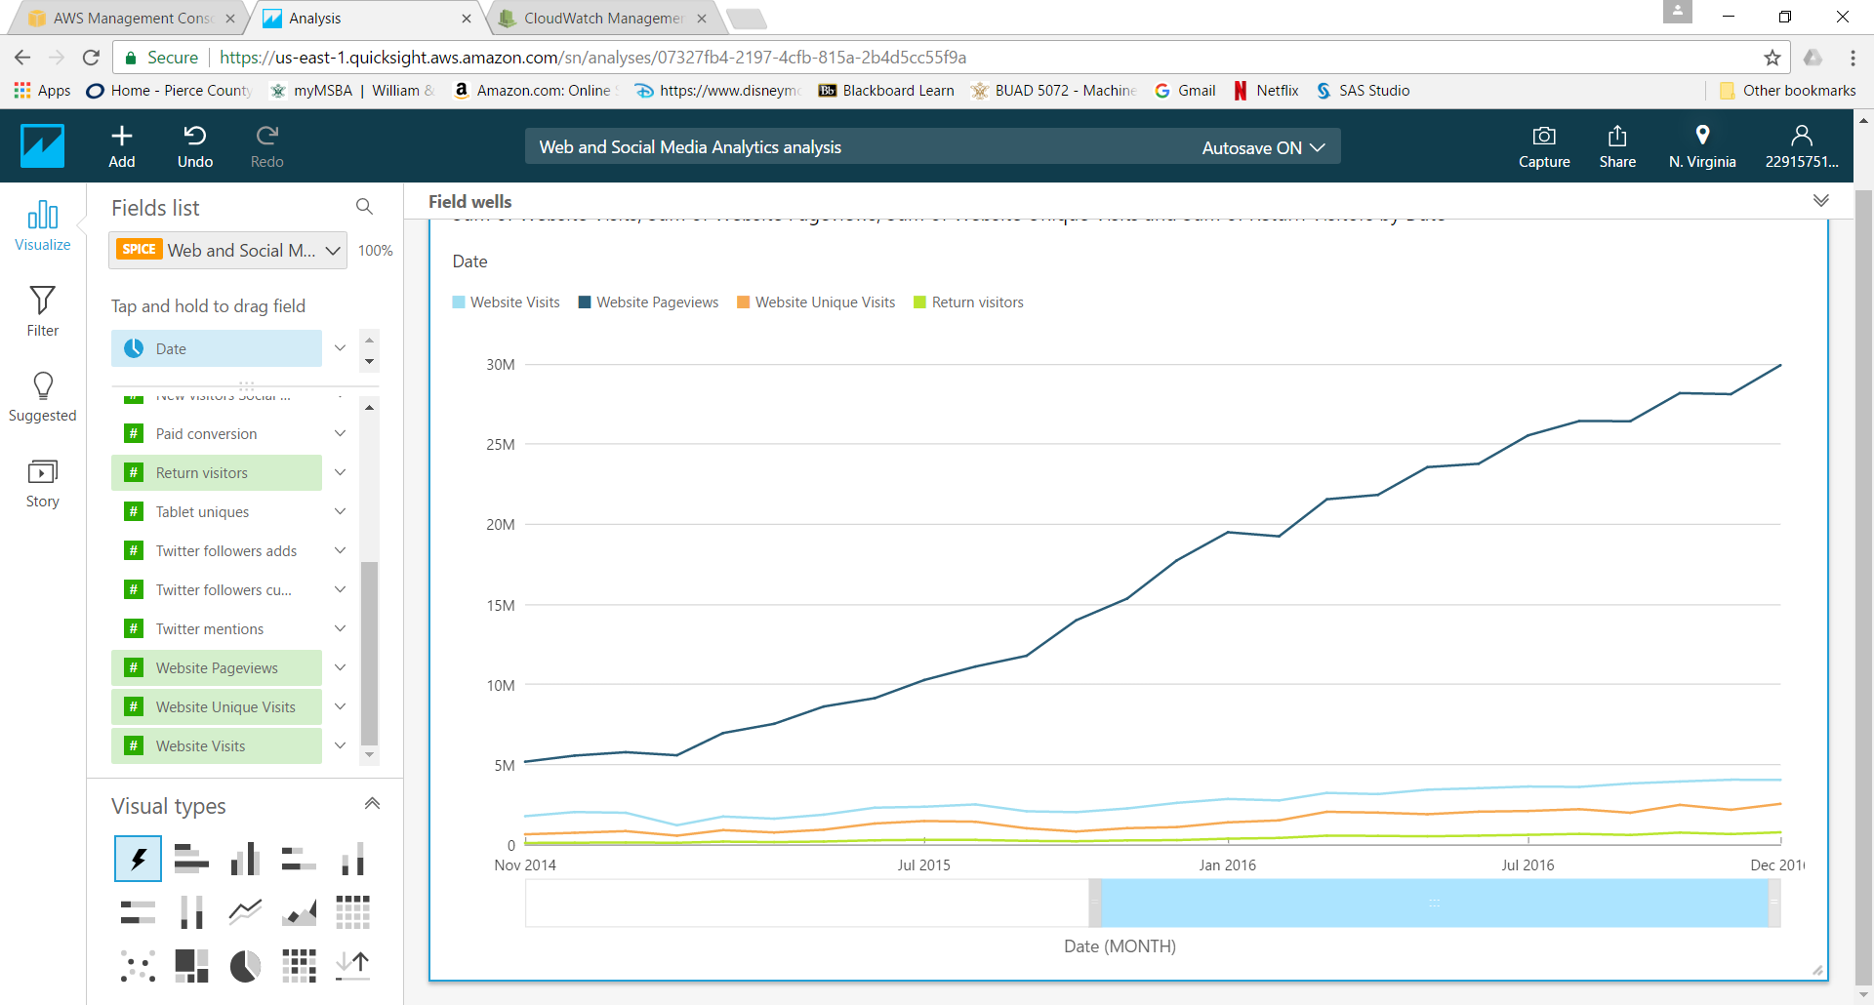

1. Click the plus sign for Add, then Add Visual

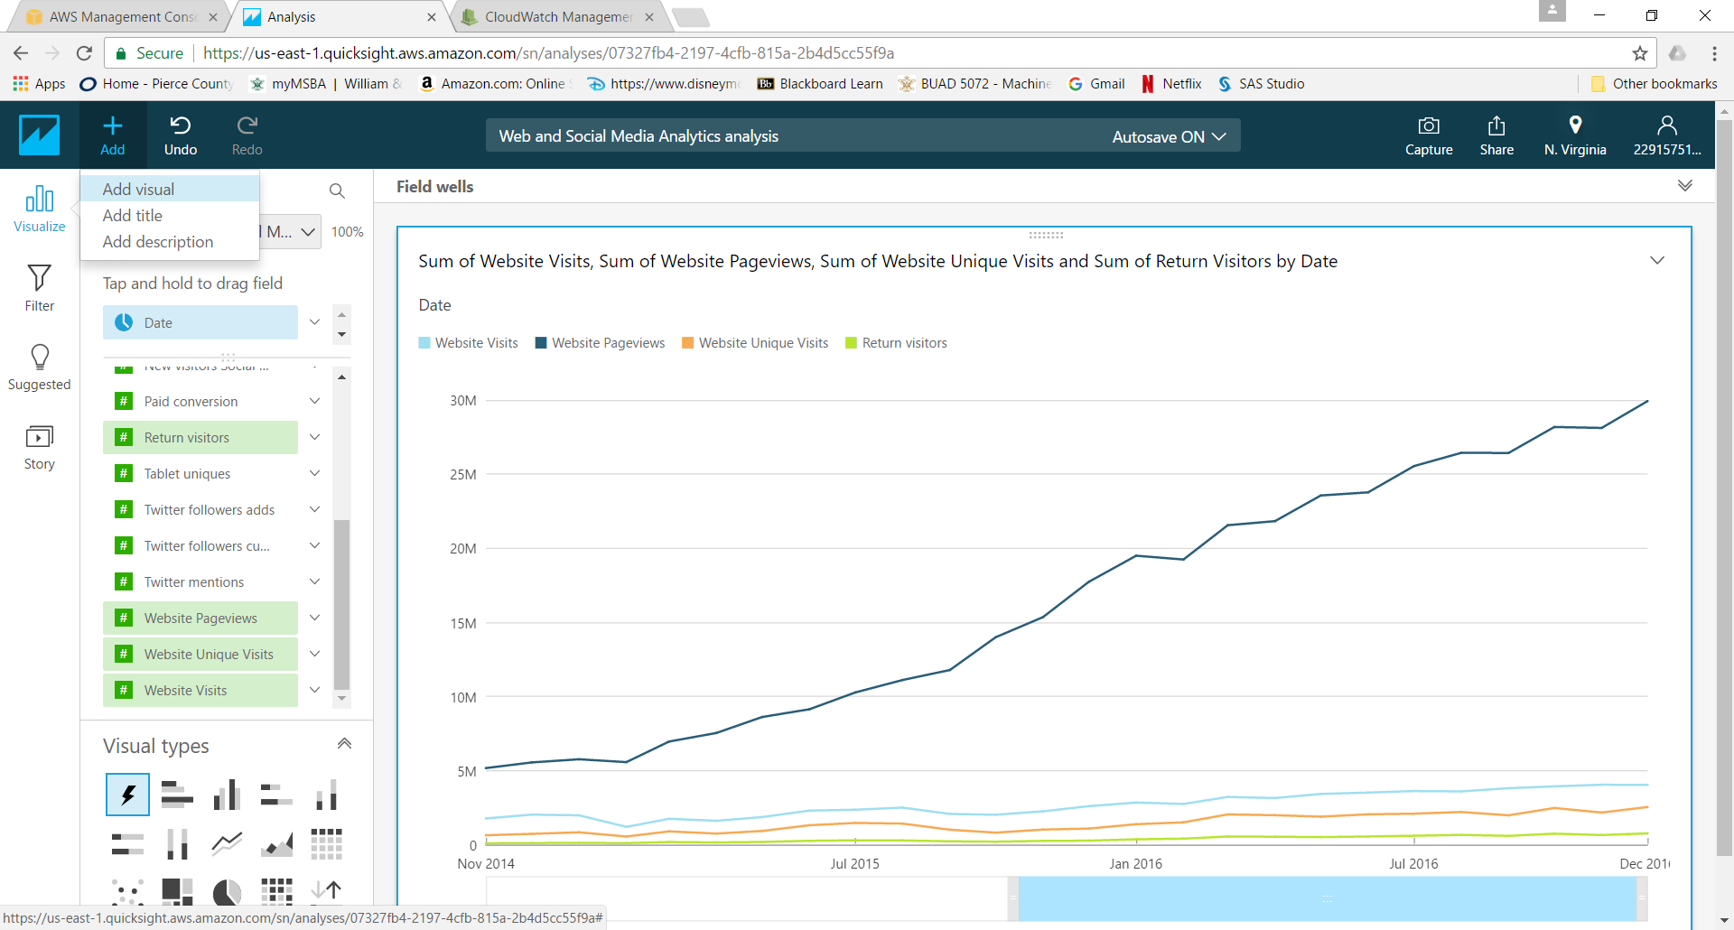

1. Click Events under fields to create a bar graph as your new visual

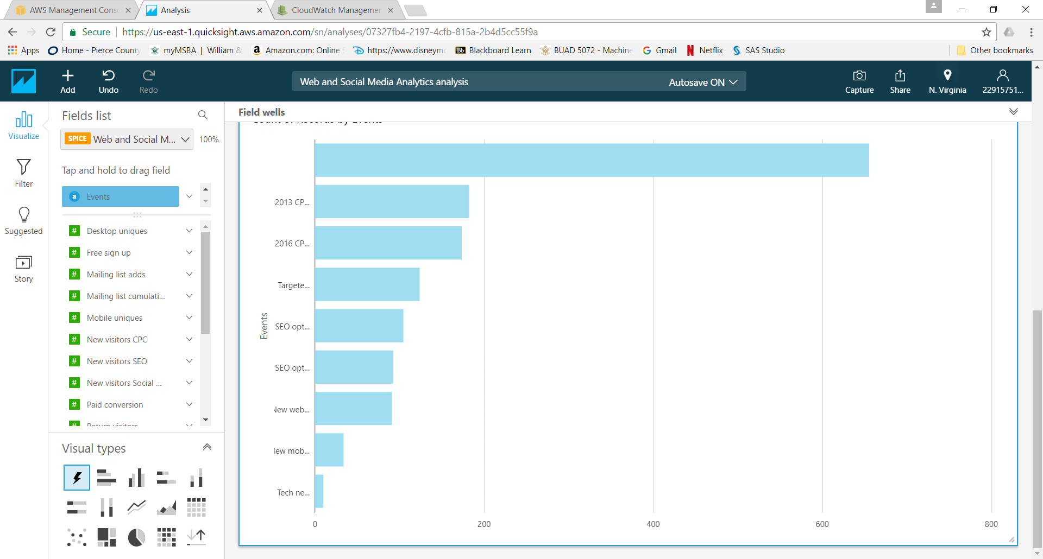

1. Add Twitter mentions as the measure for the graph

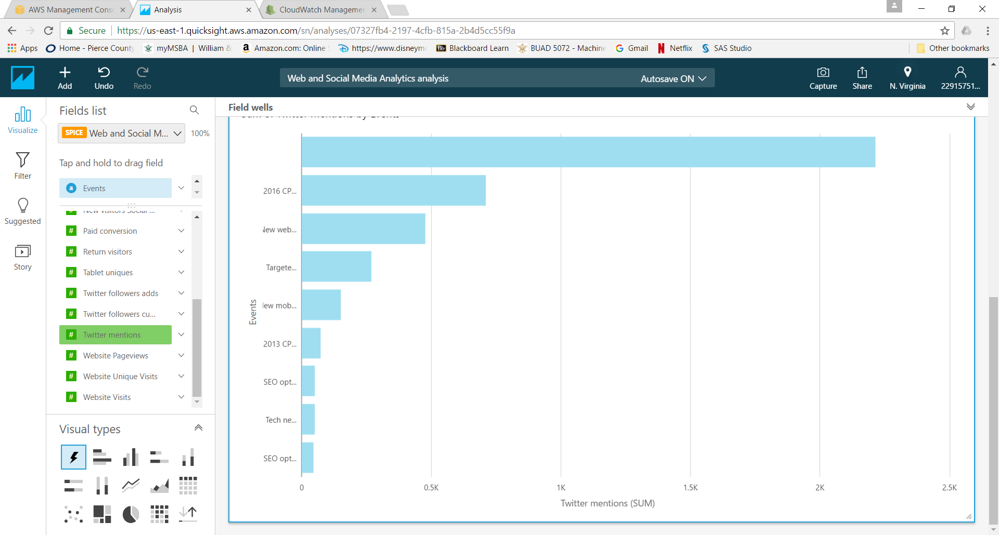

1. Add a filter to the data by clicking Filter on the sidebar, then add filter
2. Select Date, then Before Jan 1, 2016
3. Click Apply

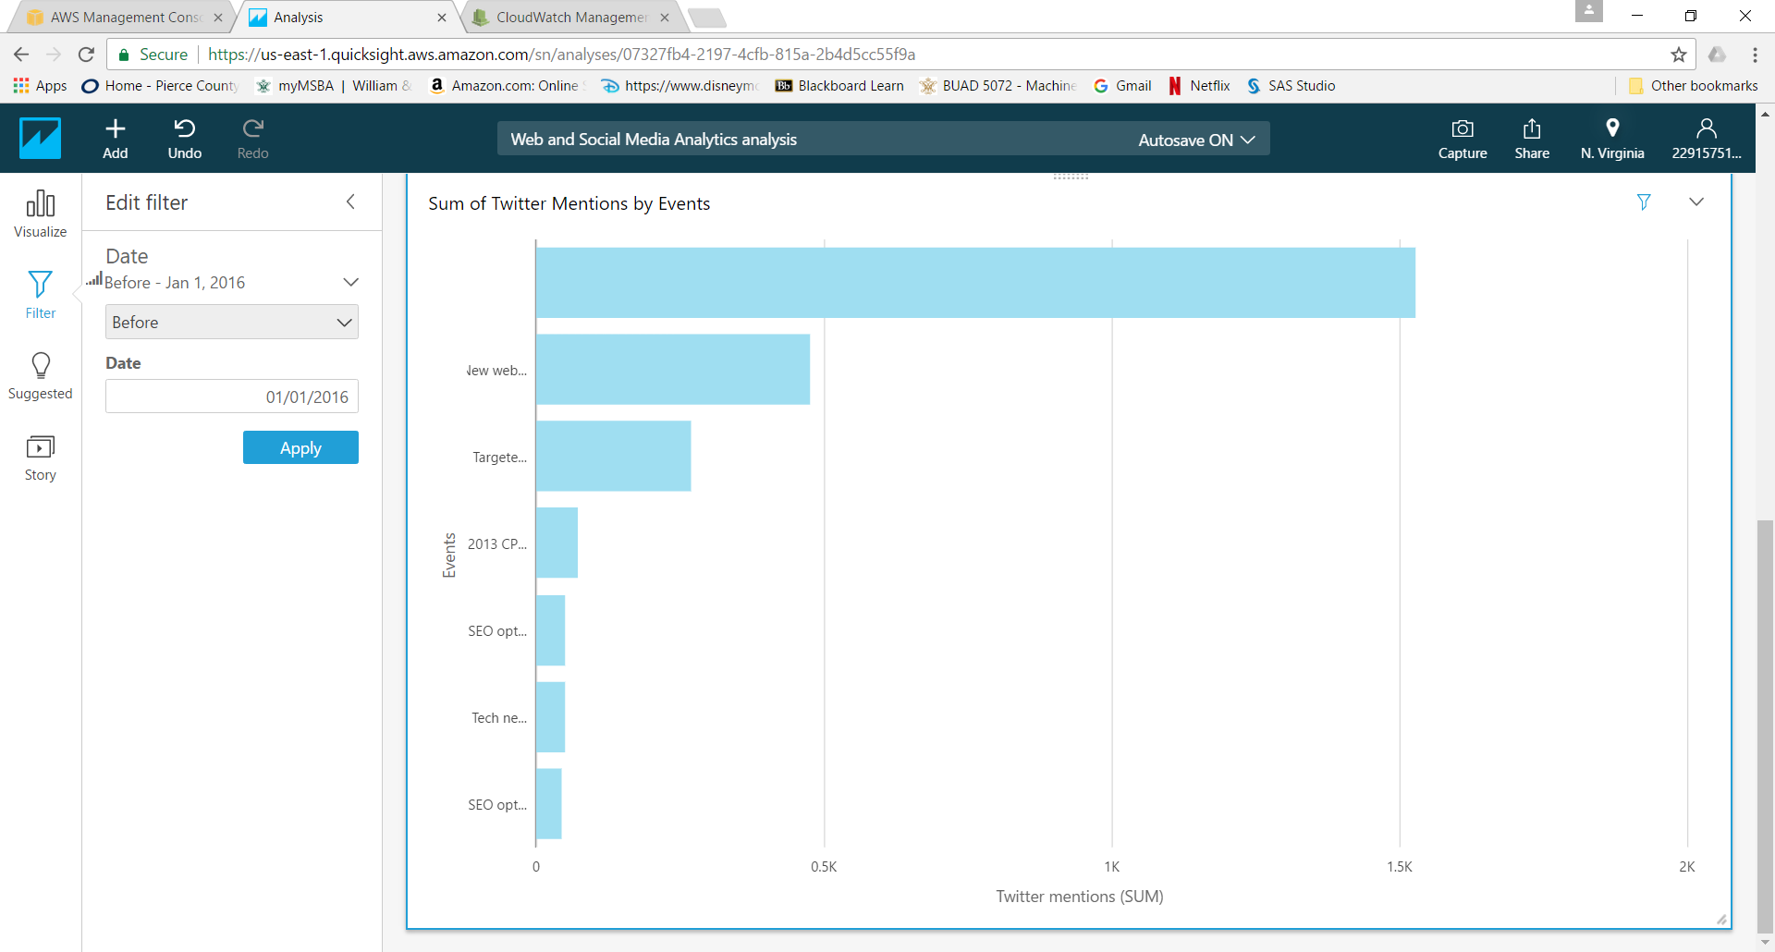

1. Resize the charts by clicking the bottom right corner and dragging, and reposition them by clicking the top center of the chart and dragging

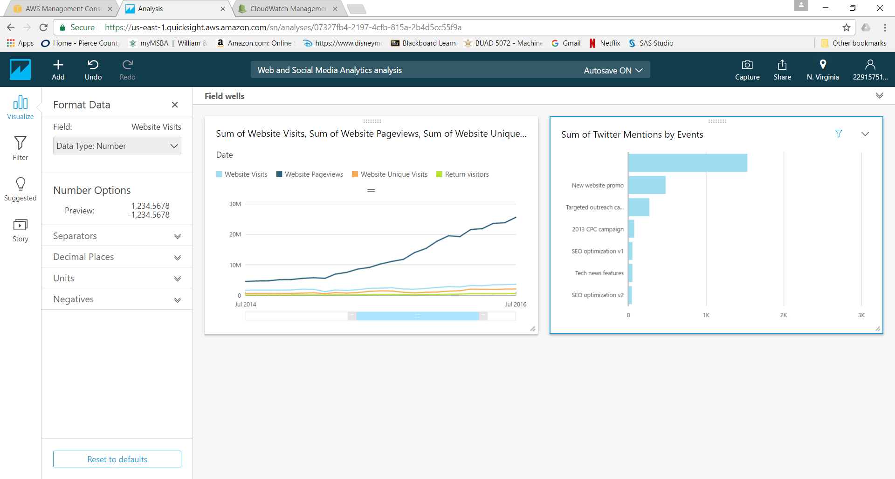

1. Go back to the QuickSight home by clicking the top left corner. Notice the visual you created is listed under All analyses
2. Click Manage Data

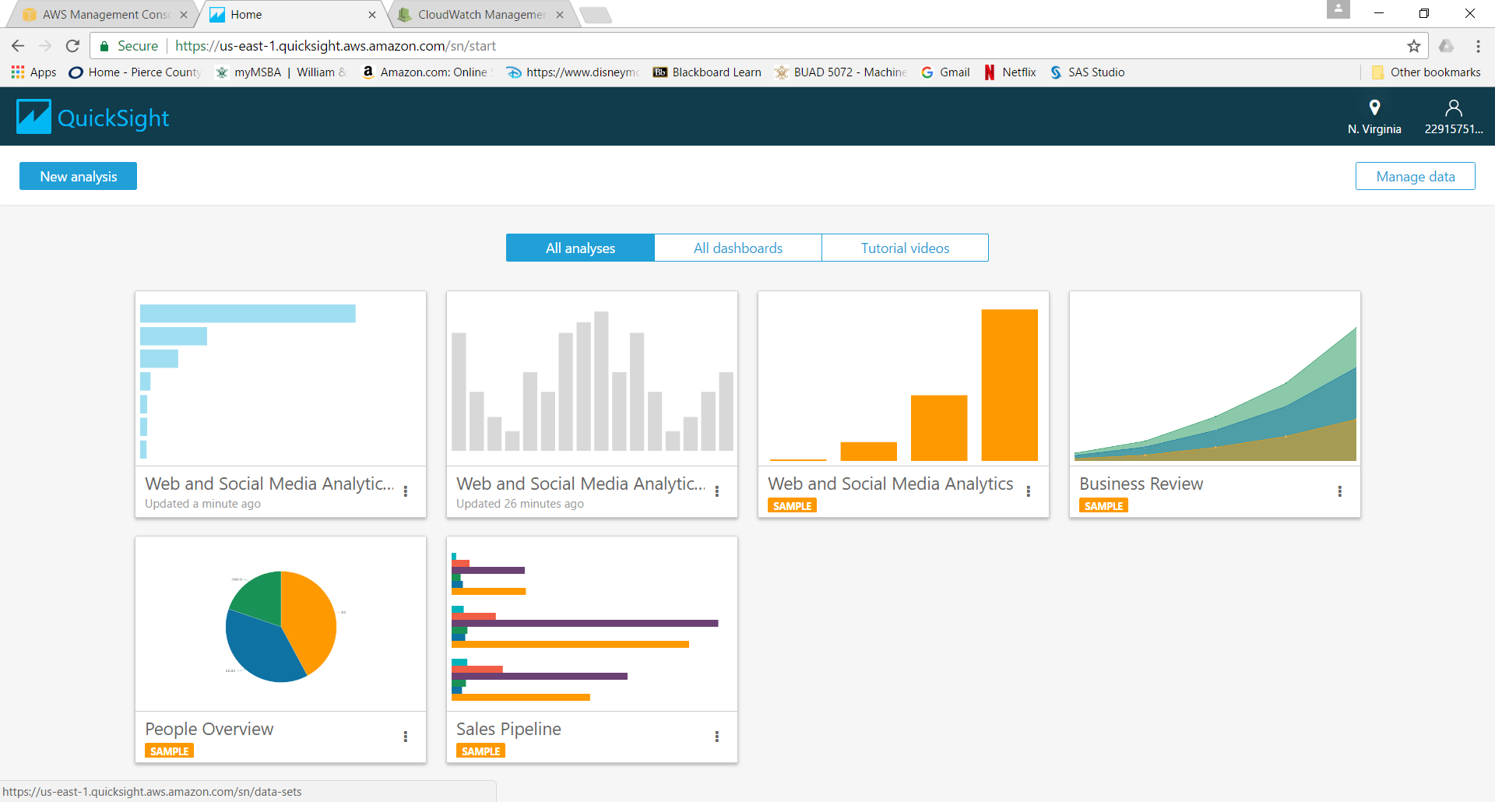

1. Notice how much of your SPICE capacity you have left

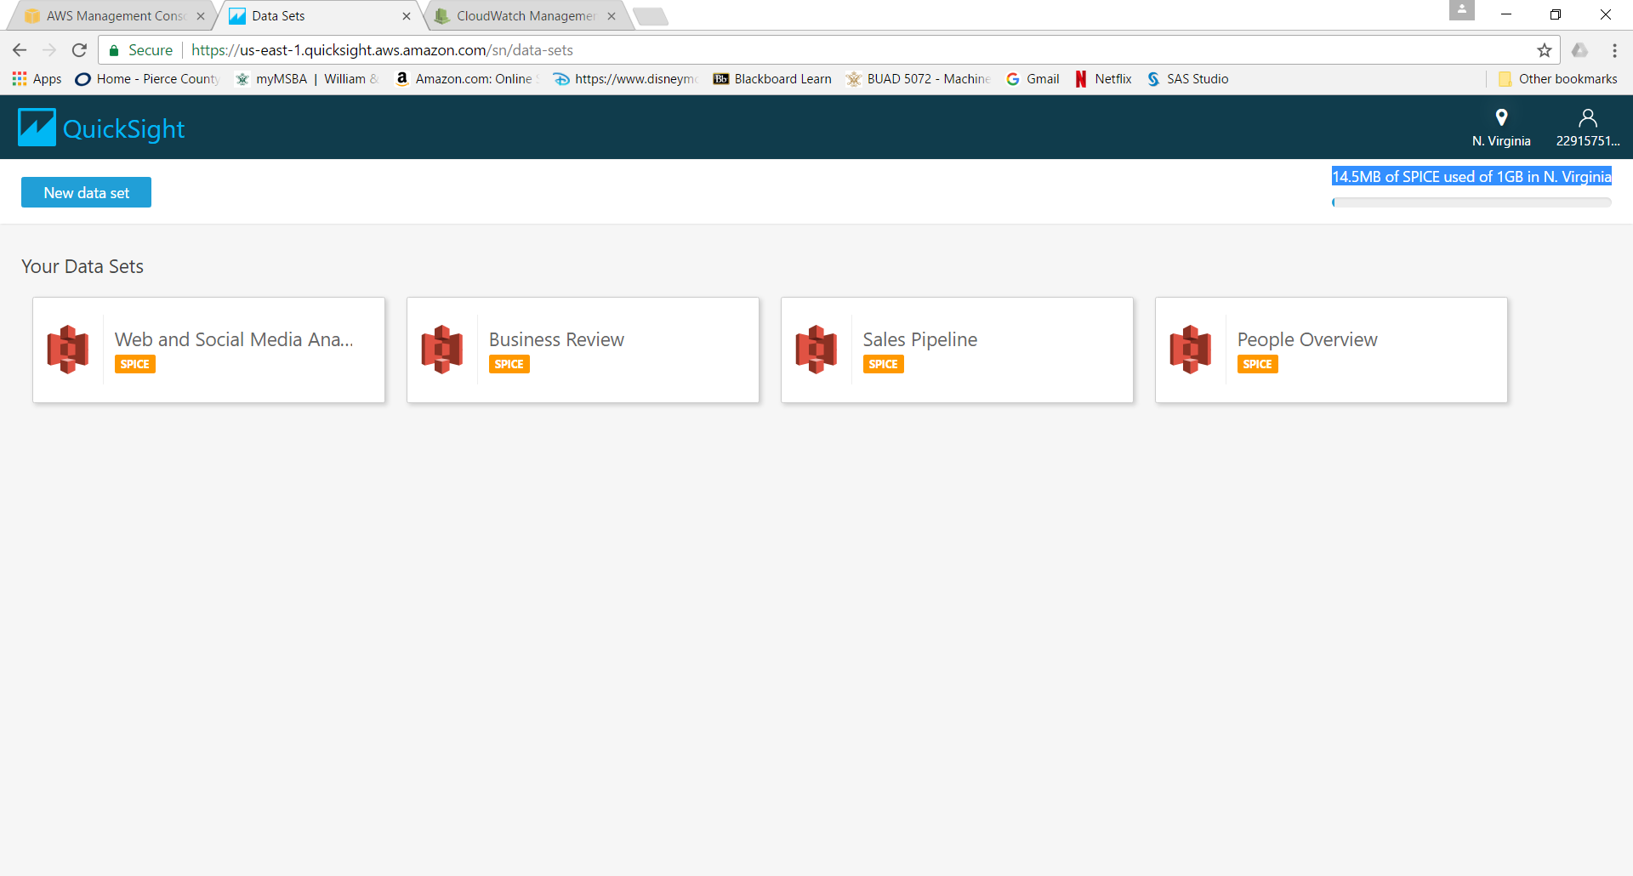

1. Click the user icon in the top right corner and select Manage QuickSight

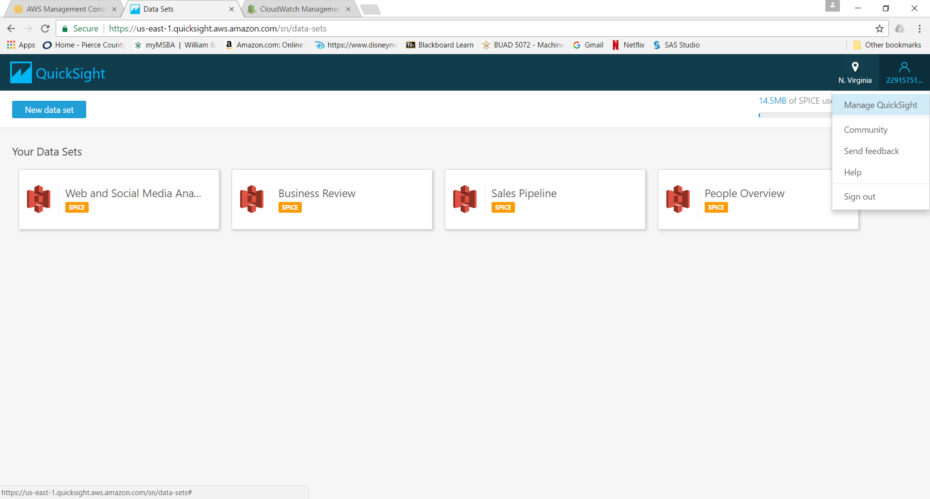

1. This shows you your usage, account settings, and users

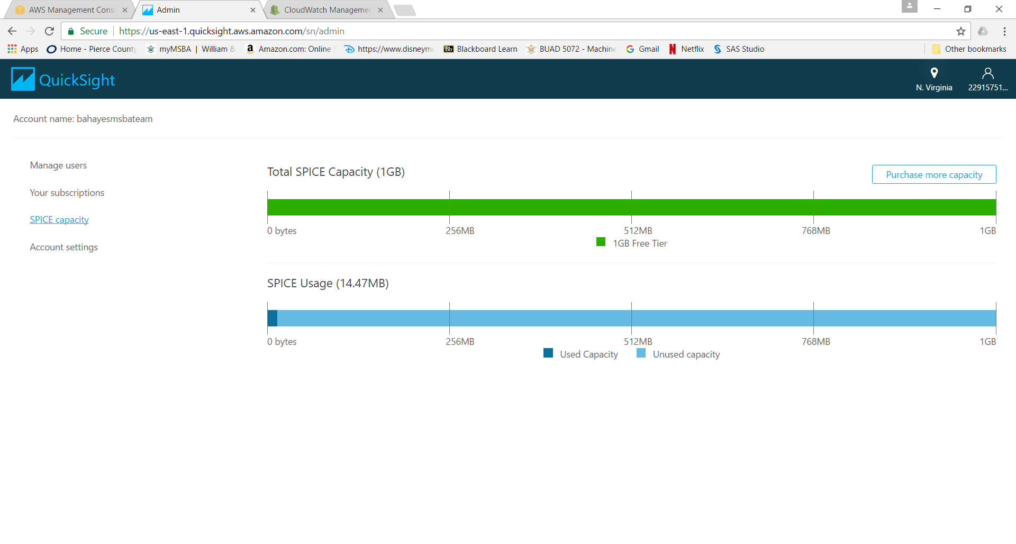

1. Log out of QuickSight by selecting the user icon in the top right corner and selecting Sign out
2. You can terminate your QuickSight account by selecting manage QuickSight, Account settings, Unsubscribe

